Thematic Spelling Dictionary

What is Thematic Spelling Dictionary
# Source: AI Source: Provided by: [Data Path: Persons Table -> ID Column: 1, Name_En Column: Motasem Essam] -> From: [Chatgpt (GPT-4-turbo)] on [7/30/2025]
A Thematic Spelling Dictionary (also called a subject-based or topic-specific spelling dictionary) organizes words by themes or subject areas instead of alphabetically. Its primary goal is to help users learn and spell vocabulary within a specific context, such as science, math, business, or everyday life.

✅ Key Features:
# Source: AI Source: Provided by: [Data Path: Persons Table -> ID Column: 1, Name_En Column: Motasem Essam] -> From: [Chatgpt (GPT-4-turbo)] on [7/30/2025]
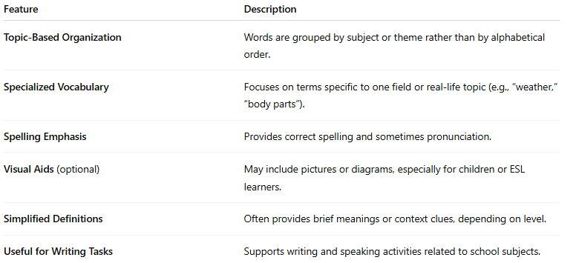
Feature | Description
Topic-Based Organization | Words are grouped by subject or theme rather than by alphabetical order.
Specialized Vocabulary | Focuses on terms specific to one field or real-life topic (e.g., “weather,” “body parts”).
Spelling Emphasis | Provides correct spelling and sometimes pronunciation.
Visual Aids (optional) | May include pictures or diagrams, especially for children or ESL learners.
Simplified Definitions | Often provides brief meanings or context clues, depending on level.
Useful for Writing Tasks | Supports writing and speaking activities related to school subjects.

👤 Target Audience:
# Source: AI Source: Provided by: [Data Path: Persons Table -> ID Column: 1, Name_En Column: Motasem Essam] -> From: [Chatgpt (GPT-4-turbo)] on [7/30/2025]
- Students learning subject-specific vocabulary
- ESL/EFL learners
- Teachers planning themed lessons
- Writers or editors in technical fields

📘 Examples:
# Source: AI Source: Provided by: [Data Path: Persons Table -> ID Column: 1, Name_En Column: Motasem Essam] -> From: [Chatgpt (GPT-4-turbo)] on [7/30/2025]
- Thematic Spelling Dictionary for Science and Technology
- Picture Spelling Dictionary by Theme (for young learners)
- Spelling Dictionary for Academic Subjects (e.g., math, social studies, geography)

🟢 Benefits:
# Source: AI Source: Provided by: [Data Path: Persons Table -> ID Column: 1, Name_En Column: Motasem Essam] -> From: [Chatgpt (GPT-4-turbo)] on [7/30/2025]
- Reinforces vocabulary in a meaningful context
- Aids memory by grouping related words
- Supports content learning and subject literacy
- Helpful in writing assignments or test prep

🔴 Limitations:
# Source: AI Source: Provided by: [Data Path: Persons Table -> ID Column: 1, Name_En Column: Motasem Essam] -> From: [Chatgpt (GPT-4-turbo)] on [7/30/2025]
- Not comprehensive for general vocabulary
- Users may need a separate general dictionary for unrelated words
- May lack detailed definitions or grammar info

